**Tree - Height of a Binary Tree**

<https://www.hackerrank.com/challenges/tree-height-of-a-binary-tree/problem>

The height of a binary tree is the number of edges between the tree's root and its furthest leaf. For example, the following binary tree is of height 2:

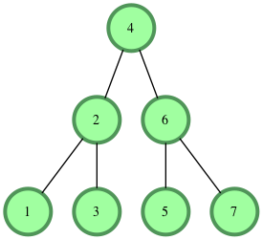

**Function Description**

Complete the *getHeight* or *height* function in the editor. It must return the height of a binary tree as an integer.

getHeight or height has the following parameter(s):

* *root*: a reference to the root of a binary tree.

**Note** -The Height of binary tree with single node is taken as zero.

**Input Format**

The first line contains an integer n, the number of nodes in the tree.  
Next line contains n space separated integer where ith integer denotes node[i].data.

**Note**: Node values are inserted into a binary search tree before a reference to the tree's root node is passed to your function. In a binary search tree, all nodes on the left branch of a node are less than the node value. All values on the right branch are greater than the node value.

**Constraints**

* *1 <= node.data[i] <= 20*
* *1 <= n <= 20*

**Output Format**

Your function should return a single integer denoting the height of the binary tree.

**Sample Input**

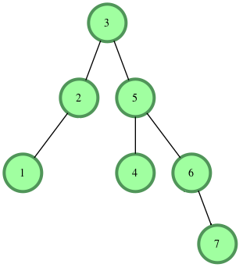

**Sample Output**

3

**Explanation**

The longest root-to-leaf path is shown below:

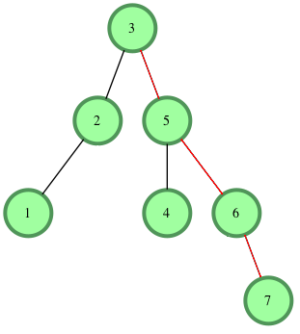

There are 4 nodes in this path that are connected by 3 edges, meaning our binary tree's height = 3.